**CS 422**

**USER INTERFACE DESIGN AND PROGRAMMING**

**Group Project #2**

**UIC Campus Wear Application**

**Group 4**

**Ajay Marampalli**

**Sai Suryateja Sakuru**

**Vineeth Myneedi**

**TABLE OF CONTENTS**

**Executive Summary** **3**

**Introduction to project** **3**

**Focus Setting and User Research** **3**

**Design Process** **4**

Affinity Diagram 4

User needs 4

Breakdowns 4

Design opportunities 5

Personas 5

Key User Tasks 6

Scenarios 7

Storyboards 8

**Design Solution** **9**

Task Flow Diagram 9

Annotated Wireframes 10

Iterative Design Process 10

Feedback 11

Changes 11

High Fidelity Prototype 12

**User Testing** **12**

Think aloud User Testing 12

A/B User Testing 13

**UI Implementation** **15**

**APPENDIX** **16**

# 

# Executive Summary

The Report presented the predominant challenges in the UIC campus wear web application and design solutions based on the results of various focus group interviews.

Problems:

Product is out of stock when you need it the most, filtering through various options such as (size, price range, delivery preferences) at one glance, lack of information on deals and offers

Solutions:

Can order products ahead of time, can apply multiple filters to choose the right product, and see daily deals, offers and advertisements on the main screen.

# Introduction to project

The project focuses on designing the website to buy university merchandise for University of Illinois at Chicago (UIC) students. This application is committed to serving students and the rest of the UIC community. Our website allows users to browse catalogs, reviews, and ratings, order delivery, and pay for products. The base idea of our project is [Hype and Vice](https://www.hypeandvice.com/) website which is an online shopping portal for university students with access to multiple university merchandise. The main motto is to embody the spirit, passion and lifestyle of your college years while fostering community and fandom.

# Focus Setting and User Research

Before designing the interface it is very important to brainstorm ideas with your group to identify the focus setting. After identifying the focus setting, prepare a discussion guide to conduct user research using focus groups and interviews. Analyze the user research data to determine user needs.

Developed a focus setting “We want to understand how users would make decisions about what merchandise they would like to buy and how their decision is influenced by different circumstances. We will then identify the constraints and barriers they face when choosing the items to buy, the selection of university merchandise and their preferences.” User research is a key step in our entire design process as UXD is based on the mantra “The user is not like me”. Focus groups are used to uncover the user's needs and wants. Interview is a conversation with a purpose. Have used Campus wardrobe, Shop college wear as design probes. Conducted 2 focus groups with each containing 5 individuals and 1 semi-structured interview with target users (UIC students) using discussion guides in a clear and professional manner. Discussion guide and transcripts are attached in the appendix.

# Design Process

## Affinity Diagram

Affinity diagrams help organize information into groups of similar items—particularly useful when analyzing qualitative data or observations. The affinity diagram helps to identify problems, create ideas, convert complex ideas into simple solutions and help groups find concensus.

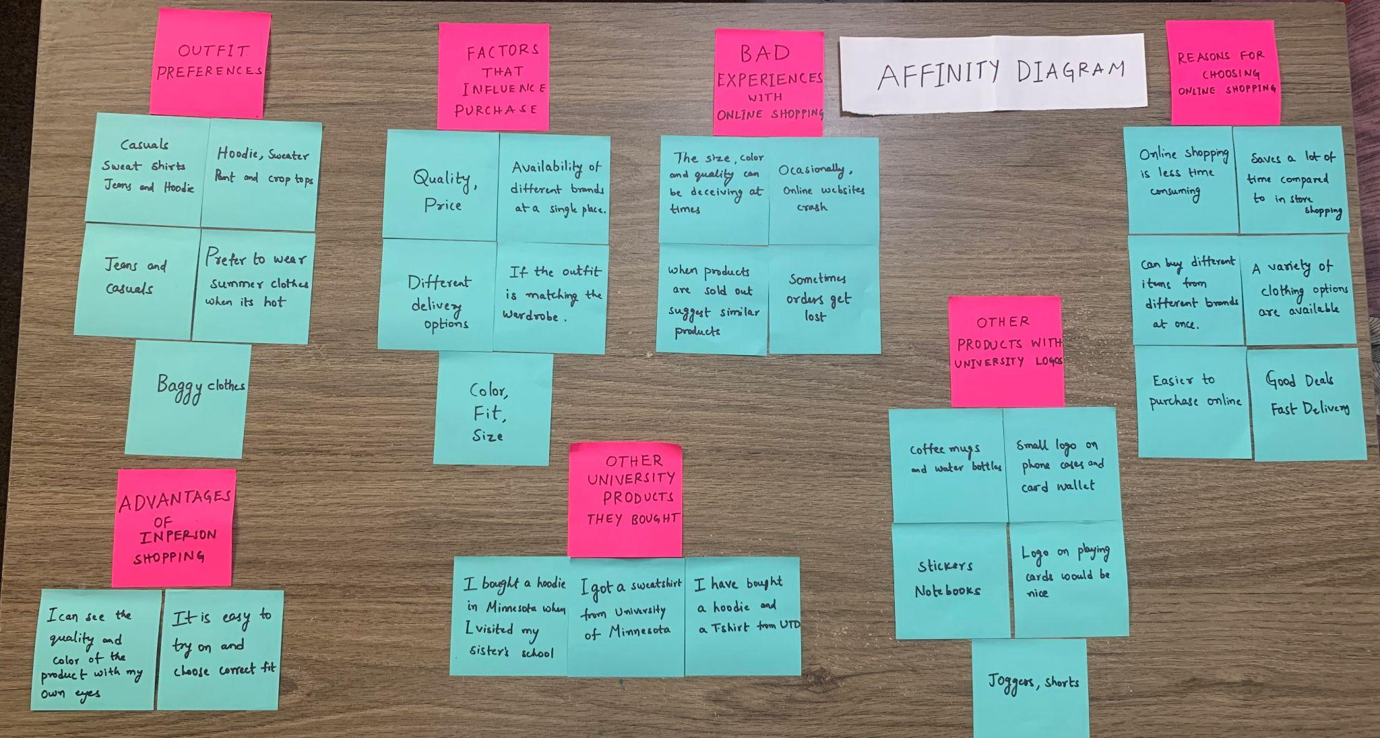

## User needs

* Deals and Discount Offers
* Quality of the product
* Affordable budget range to choose the product
* The appropriate size of the outfits
* Fast delivery of the product

## Breakdowns

* Late arrival of the product
* Damage to the product
* The product did not live up to the product description on the online shopping platform.
* The products are not sorted based on prices

## Design opportunities

* Perks on late arrivals and damaged product
* Giving a price range feature to set the required prices
* Return/Replace for the products which did not live up to the product description

## Personas

In user experience and user interface (UX/UI) design, a persona is a fictional character that represents a typical user of an app, website, or other product. A user persona helps clarify your target audience. It helps you identify the user. A persona helps you understand their needs.It gives you an understanding of user behavior.

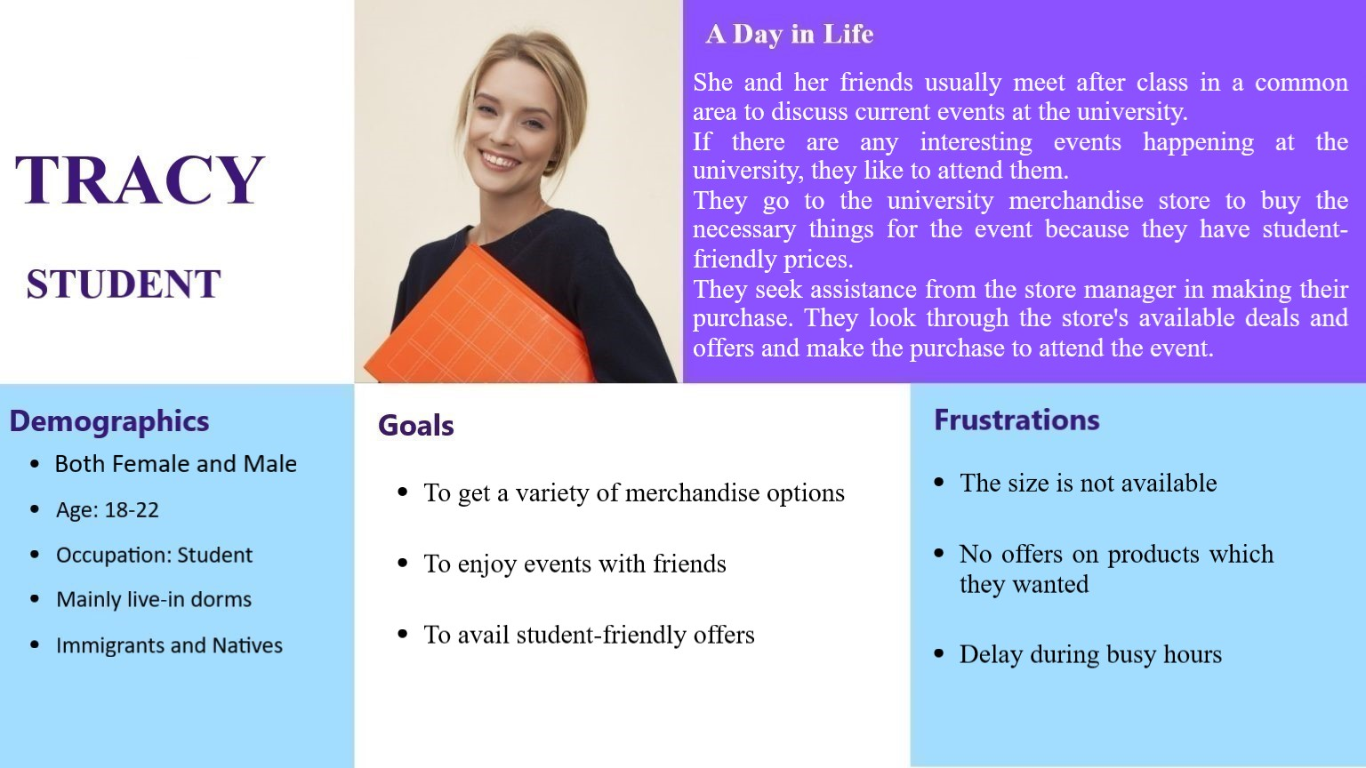

Persona 1

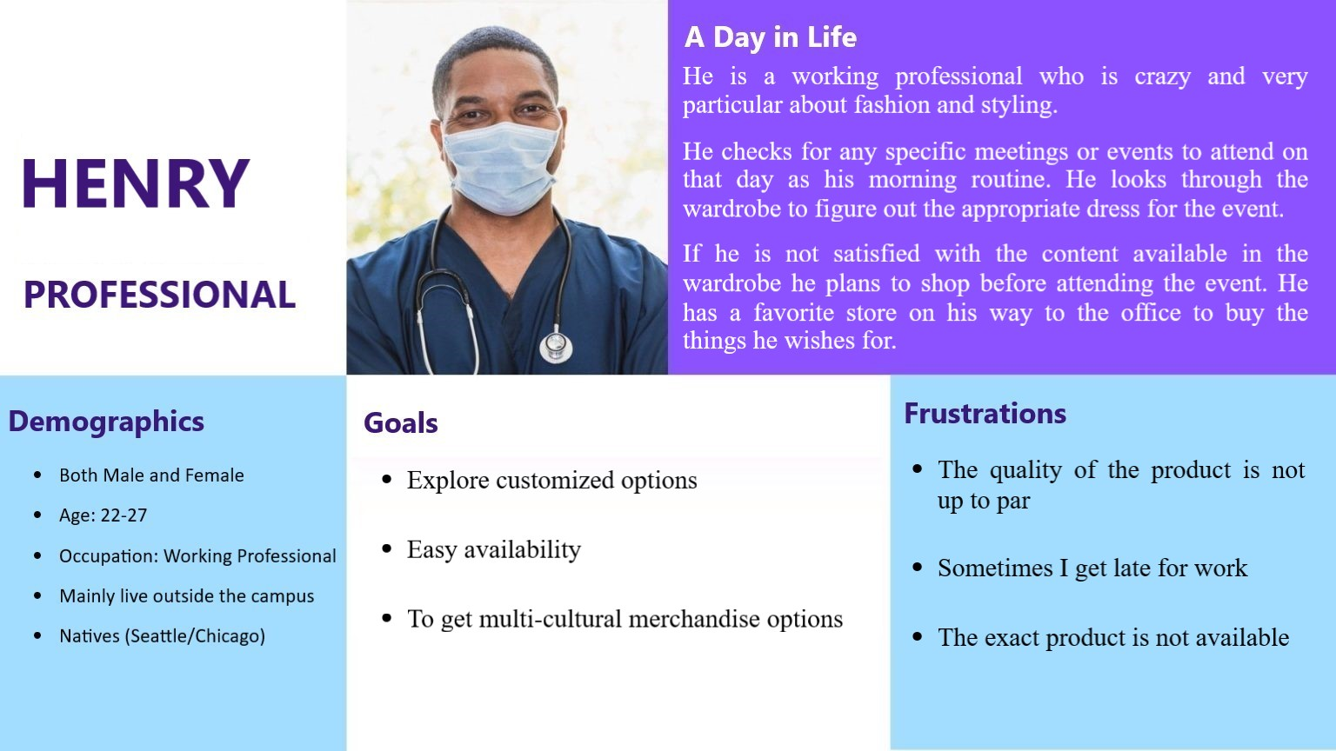

Persona 2

## Key User Tasks

User key tasks 1: User wants to buy the product

1. Find their required product in the catalog: Most people try to find the wished product in the available catalog when they visit any merchandise store
2. To satisfy the needs: Most of the events occurring require a specific kind of attire which is mandatory, so people try to get their hands on that specific product at the store.
3. Browsing through the available catalog: They try to find the specific product by searching the available catalog by modifying the filters.

User key tasks 2: User wants to only buy the specific product

1. Explore different kinds of products: People tend to have different kinds of clothing preferences varying due to differences in the culture
2. To adapt to their desired lifestyle: People define their lifestyle based on influence from the family, social media
3. Explore filter options: They achieve finding their preferred clothing by using the different options of filters such as size, material, color, brand

User key task 3: User wants to find a product in their budget range

1. Find clothing in an appropriate budget range: People generally tend to have a specific budget range, which varies based on several factors.
2. To plan their expenditure wisely: People try to spend money by prioritizing their needs and wants
3. Setting an appropriate budget using filters: They set their desired budget on the website using filters to sort items in that specific price range.

## Scenarios

User scenarios are stories which designers create to show how users might act to achieve a goal in a system or environment. Designers make scenarios to understand users’ motivations, needs, barriers and more in the context of how they would use a design, and to help ideate, iterate and usability-test optimal solutions. 3 scenarios are provided in the context of our app to help you get an idea of our key features and target users. (see appendix for 3rd scenario and storyboard)

**1. Filtering**

User: John is a student who is a perfectionist and likes to have everything according to his taste and interest which vary widely.

User Needs:

* Easy filtering
* Quick purchase of the preferred product
* Availability of multiple filter tools

Scenario: “John has a habit of browsing through a variety of options before making a final decision on a product. Whenever he visits any store, he looks for the options provided for all the available items in the store and makes an informative order. Whenever he visits a store, it takes up a lot of time to browse through the available catalog. In our application, John can filter through various options such as (size, price range, delivery preferences) at one glance. Through making the appropriate filter selections, John spectates at the available options and makes a purchase.”

**2. Deals and Offers**

User: “Alan is a new student who would like to get information regarding the available deals and offers at the university merchandise store.”

User Needs:

* Available offers at the store
* Receives mail when deals are updated at the store

Scenario: “Alan is a new student who would like to know about the available deals and offers at the university merchandise store. He has to visit the store on a daily basis to have up-to-date information regarding the available offers. In our application, the users can subscribe for alerts regarding the deals through the website. Alan subscribes to the alerts regarding the deals through the website. He sees an offer on a pair of shoes he wants and decides to buy them based on the offer. He routinely utilizes the notifications through mail to receive special discounts on his products.”

## Storyboards

|  |  |
| --- | --- |
| Storyboard 1: Filters | Storyboard 2: Deals & Offers |

# 

# 

# Design Solution

## Task Flow Diagram

**Taskflow diagram** shows how tasks are ordered to flow from one to the other naturally according to the user's mental models. Each box in the task flow becomes a screen. Each decision point becomes an interaction the user will take to make the decision.

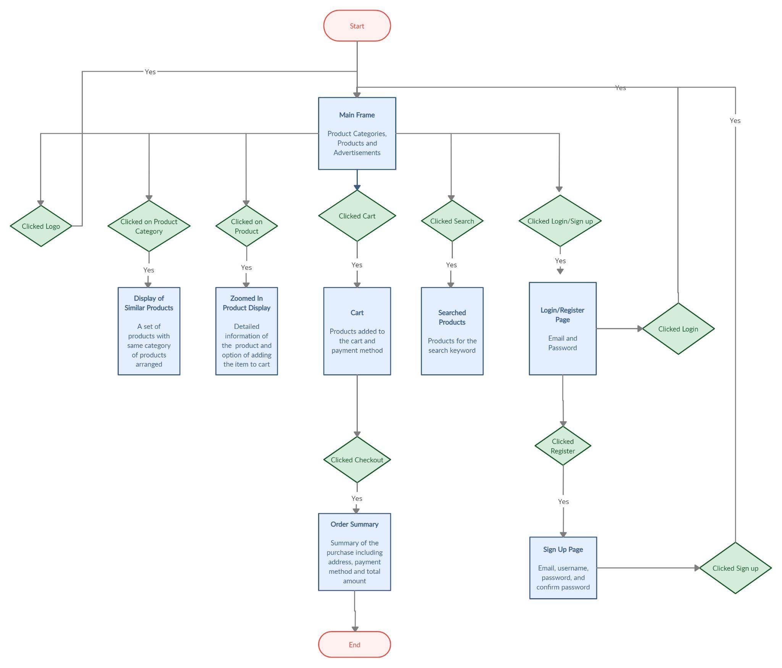

## 

## Annotated Wireframes

Abstracted views of the design of each screen in your app, site, system, etc. Every planned feature or functionality is represented.

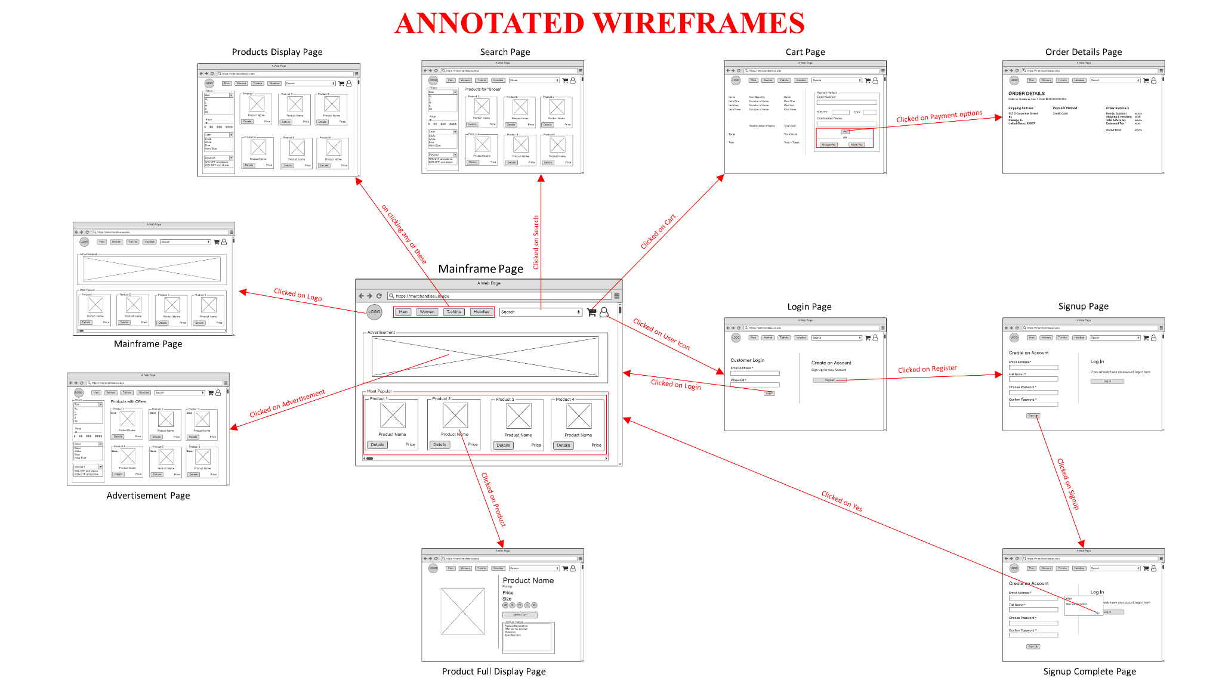

**Link to wireframes(Balsimiq screens) :**

<https://drive.google.com/drive/folders/10xojnhe6OxHAxrpUfjNoOLI-RAVgIKU9?usp=sharing>

## Iterative Design Process

We tested the wireframe with two users to get their feedback before developing the interactive pixel-perfect prototype. They suggested that there is no need for a sign-up alert screen, you can direct the user to the main screen after clicking on the signup button. Another suggestion was that in top products of the main screen, you can remove details and display ratings as you are ready directed to the full product display screen upon clicking on the image of the product. We have incorporated these changes in our pixel perfect prototype used for mid point critique.

**Link to High fidelity prototype used for mid-point critique** - <https://invis.io/AD12KR3RGJWX>

## Feedback

Feedback received during mid point critique:

1. Include multiple filters selection

2. Should be able to select multiple filters in UI implementation

3. Improve Color selection of UI

4. Make a nice logo, use drop-downs on the home page instead of 4 buttons & add text reviews.

5. Alert on adding something to cart whether to continue shopping or checkout

6. Change Product Description Box

## Changes

Annotated changes incorporated from feedback on mid-point high-fidelity prototype

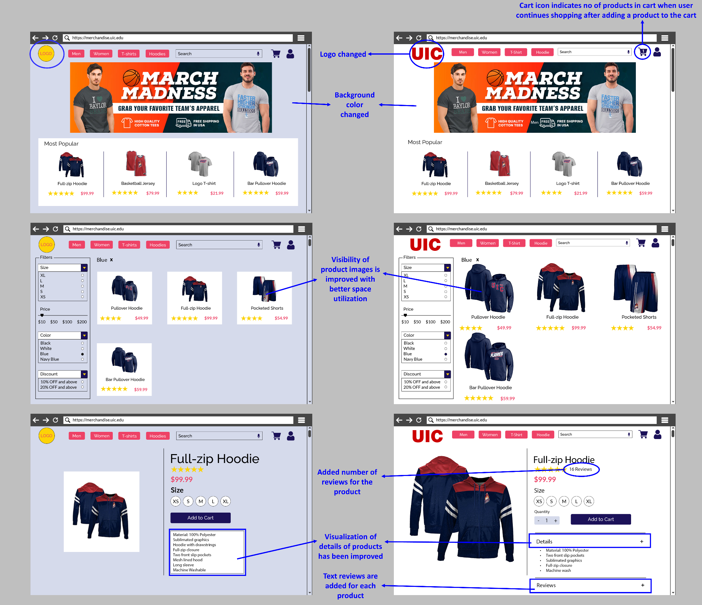

## High Fidelity Prototype

Revised set of high-fidelity prototypes from the mid-point versions documenting all transitions and interactions for each screen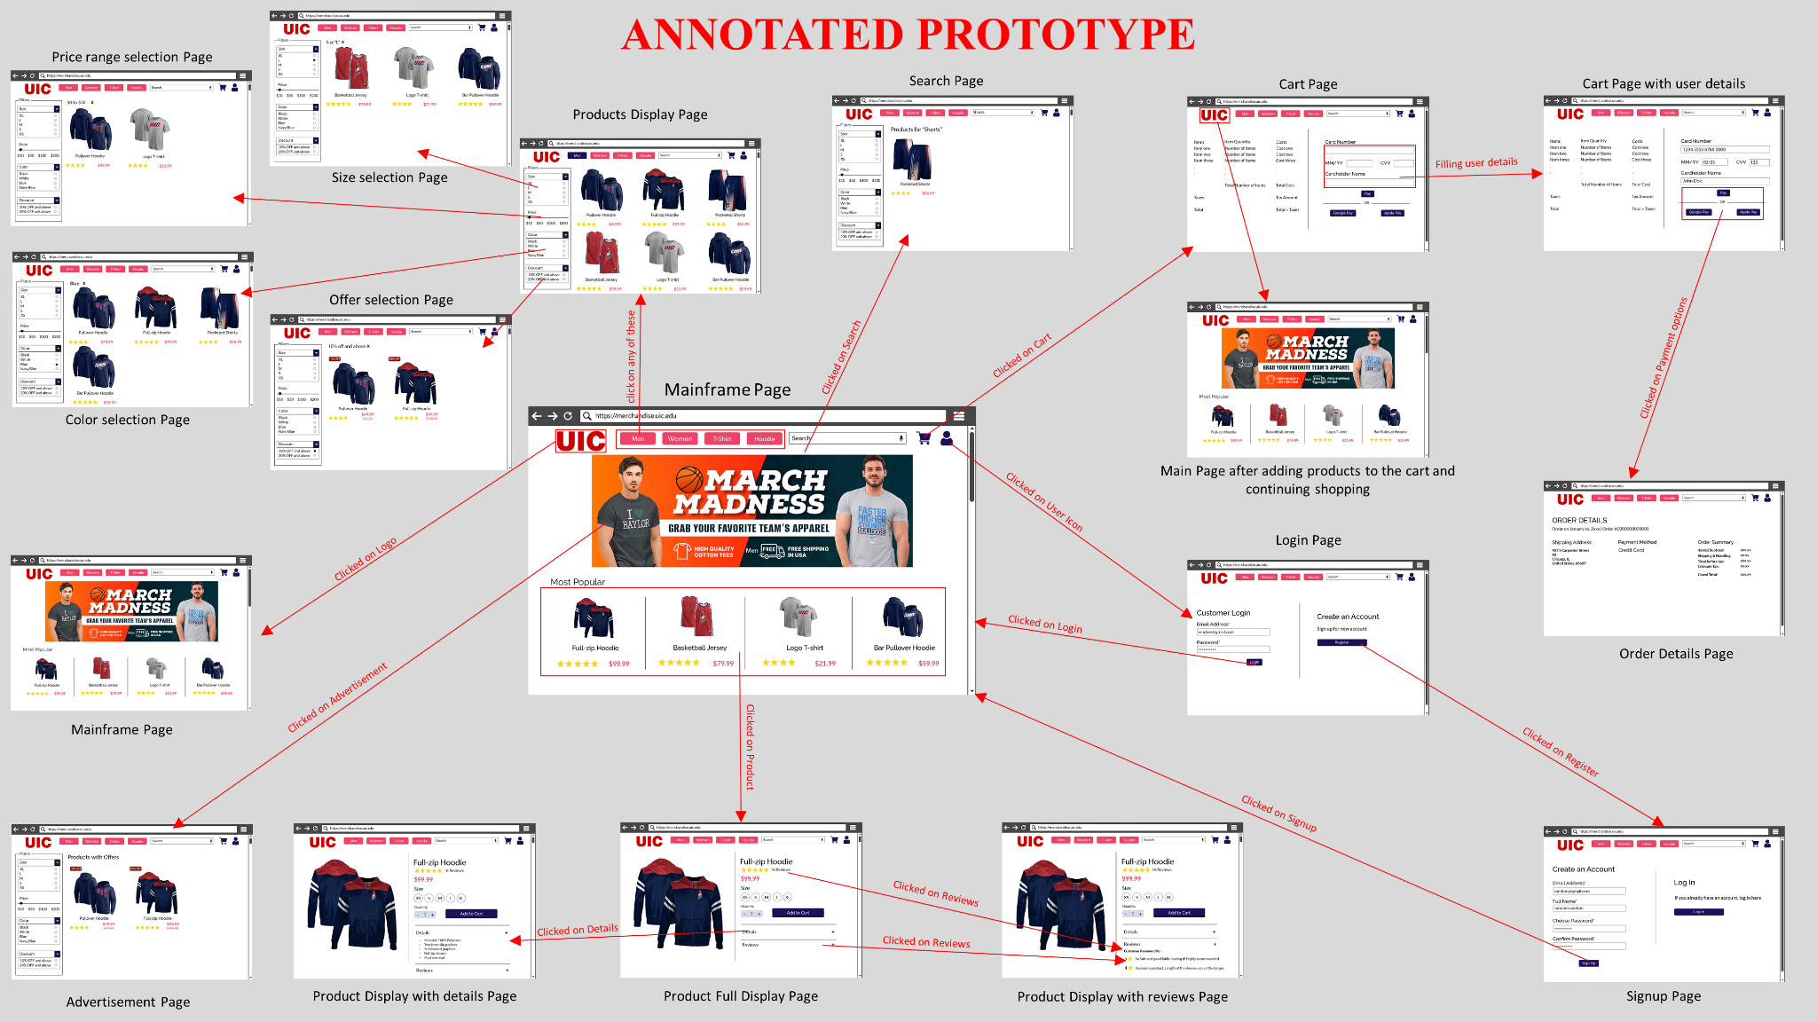

**Link to Final version of high fidelity prototype -** <https://invis.io/K612N5YIZMSY>

# User Testing

## Think aloud User Testing

User Tasks:

1. Buy a full zip hoodie of size small and check out the product
2. Sign Up for the application
3. Buy a discounted item using the ad on the main page

Evaluation Criteria:

1. Number of incorrect clicks
2. Time taken to complete the task

Evaluation Report of User Testing with 2 users:

Success criteria for Task 1: User should reach order details screen

| User | Number of incorrect clicks | Time taken to complete the task(sec) |
| --- | --- | --- |
| 1 | 0 | 7 |
| 2 | 0 | 8 |

Success criteria for Task 2: User should reach Main Screen after signing up

| User | Number of incorrect clicks | Time taken to complete the task(sec) |
| --- | --- | --- |
| 1 | 0 | 3 |
| 2 | 0 | 3 |

Success criteria for Task 3: User should reach order details screen

| User | Number of incorrect clicks | Time taken to complete the task(sec) |
| --- | --- | --- |
| 1 | 1 | 6 |
| 2 | 0 | 8 |

Feedback from the users:

1. The website is pretty good and easy to use. Although I was using the website for the first time, I was able to easily navigate and complete the given tasks.
2. The website was well designed and functional. Make sure to add a few more images to implement scroll functionality.

## A/B User Testing

A/B Testing (also known as Split Testing) is a website optimisation technique that involves sending half your users to one version of a page, and the other half to another, and watching the web analytics to see which one is more effective in getting them to do what you want them to do.

Links to prototypes:

**Prototype A:** <https://invis.io/BF12LN6L4QZP>

**Prototype B:** <https://invis.io/VF12LN0YKCYZ>

|  |  |
| --- | --- |
| Prototype A | Prototype B |

Changes between Version A and Version B:

1. Background color is changed. (Color Theory)
2. Grid layout is used in both versions. Version A has better space utilization than version B. (gutter space between modules is reduced)
3. Figure-ground principle was put to use in Version A.
4. Visibility for images of the products is better in Version A.

Null Hypothesis: The number of incorrect clicks participants got on Version A will be equal to the incorrect clicks participants got on Version B.

Alternate Hypothesis: The number of incorrect clicks participants for Version A is going to be lesser than that of Version B because *we changed the background color in Version B to be colorful.*

User Task for A/B Testing: Sign up for the website and then buy any product.

Evaluation Criteria:

1. Number of incorrect clicks
2. Time taken to complete the task

Evaluation Report of User Testing with 2 users:

Success criteria for Task: User should reach order details screen

**Version A**

| User | Number of incorrect clicks | Time taken to complete the task(sec) |
| --- | --- | --- |
| 1 | 0 | 12 |
| 2 | 0 | 10 |

**Version B**

| User | Number of incorrect clicks | Time taken to complete the task(sec) |
| --- | --- | --- |
| 1 | 2 | 20 |
| 2 | 0 | 16 |

Conclusion:

The average time taken to complete the task on Version A: 11 sec

The average time taken to complete the task on Version A: 18 sec

Further statistical testing might be needed to decide which version is better

# UI Implementation

In UI implementation, we have introduced the drop down buttons for main categories(men and women) with subcategories(T-shirt, Hoodies and Shorts). In our high fidelity prototype we have categorized differently(men, women, t-shirts and hoodies). There was no option to select multiple filters in the prototype, whereas multiple filters can be selected in the website.

React - Bootstrap and material UI are used to build the website.

**The github link for UI implementation -** <https://github.com/ajaymarampally/collegewear>

Our entire project work can be found [here](https://github.com/sakurusurya2000/CS422_Project_2_CampusWear)

# APPENDIX

**Discussion Guide**

**Ajay Marampalli, Sai Suryateja Sakuru, Vineeth Myneedi**

| **Focus Statement**  **(include research context and target users)** | We want to understand how users would make decisions about what merchandise they would like to buy and how their decision is influenced by different circumstances. We will then identify the constraints and barriers they face when choosing the items to buy, the selection of university merchandise and their preferences.  Target users: students |
| --- | --- |
| **Discussion Guide** |  |
| * **Introduction** | Hello, I’m Surya, and today we’re here to do a focus group for our in-class project. This focus group is to discuss how University students make decisions about buying university merchandise.  I will lead the conversation about your experiences,regarding shopping university merchandise on-campus or through websites, while other team members record your answers.  We will also be audio/video recording this focus group if that is fine with you so we can refer to it later. All the records will be kept confidential.  This focus group will be 30 minutes long. Feel free to share your experiences and thoughts. Do you have any questions for me before we get started? |
| * **Key demographic questions** | 1. What's your name?  2. What is your major?  3. How long have you been studying at UIC? |
| * **Warm-up questions (factual answers)** | 1. What type of outfits would you prefer to wear?  2. Have you ever purchased anything online and how was it different from in person stores? What motivated you to buy things online?  3. Have you purchased any university merchandise on campus? |
| * **Main questions (open-ended discussions)** | 1. What do you look for before buying anything online?  2. What university merchandise do you buy?  3. What are the three important pointers for making a decision to buy university merchandise?  4. What were your good experiences with online shopping?  5. What were your bad experiences with online shopping?  7. What other products would you buy with university logos?  8. Have you ever purchased any merchandise from other universities? |
| **Design Probe(s)** | 1. Campus wardrobe - <https://campuswardrobe.com/>  2. Shop college wear - <https://shopcollegewear.com/> |

**Transcripts of User Research**

**Interview 1**

Interviewer:

Hello, I’m Vineeth, and today we’re here to do a focus group for our in-class project. This focus group is to discuss how University students make decisions about buying university merchandise.

I will lead the conversation about your experiences,regarding shopping university merchandise on-campus or through websites, while other team members record your answers.

We will also be audio/video recording this focus group if that is fine with you so we can refer to it later. All the records will be kept confidential.

This focus group will be 30 minutes long. Feel free to share your experiences and thoughts. Do you have any questions for me before we get started? Can we get started?

User: Yes

Interviewer: What's your name?

User: My name is Sathya

Interviewer: What’s your major?

User: I am pursuing my masters in MIS

Interviewer: How long have you been studying at UIC?

User: Since last August, Fall 2021

Interviewer: What type of outfits would you prefer to wear?

User: It depends on the weather. If it's summer I would prefer to wear summer clothes, if winter then winter clothes

Interviewer: Have you ever purchased anything online?

User: Yeah

Interviewer: How was it different from in person stores? What motivated you to buy things online?

User: The size, quality and color can be deceiving in pictures. If it is in store i can see it with my eyes, try it and the buy

Interviewer: Which one do you prefer?

User: If I have time I would prefer in store. If not online purchase is the best option

Interviewer: Have you purchased any university merchandise?

User: Yeah, I got T-shirts from the store.

Interviewer: What do you look for before buying anything?(clothes related)

User: Size, color and etc

Interviewer: What university merchandise would you like to buy?

User: Sweatshirts and T-shirts

Interviewer: What are the three important pointers for making a decision to buy university merchandise?

User: Color, Fit and if outfit is matching my wardrobe

Interviewer: What were your good experiences with online shopping?

User: As of now I only had good experiences. Like all these years I never had any bad experience.

Interviewer: What other products would you buy with university logos?

User: card wallet

Interviewer: Have you ever purchased any merchandise from other universities?

User: No, I haven’t

Interviewer: Thank you guys for your time. We would like you to sign the participant sheet as we have to submit it to the professor.

**Focus Group 1: 5 users**

Interviewer:

Hello, I’m Surya, and today we’re here to do a focus group for our in-class project. This focus group is to discuss how University students make decisions about buying university merchandise.

I will lead the conversation about your experiences,regarding shopping university merchandise on-campus or through websites, while other team members record your answers.

We will also be audio/video recording this focus group if that is fine with you so we can refer to it later. All the records will be kept confidential.

This focus group will be 30 minutes long. Feel free to share your experiences and thoughts. Do you have any questions for me before we get started? Can we get started?

All: Yes

Interviewer: What's your name?

User 1: Jose

User 2: Libby

User 3: Alexa

User 4: Yosuf

User 5: Liz

Interviewer: What’s your major?

Jose: Undecided

Libby: Education

Alexa: Latina/Latino Studies

Yosuf: Civil Engineering

Liz: Engineering (Undecided)

Interviewer: How long have you been studying at UIC?

Jose: 1 semester

Libby: 1 semester

Alexa: 0 days (visiting)

Yosuf: 1 semester

Liz: 1 semester

Interviewer: What type of outfits would you prefer to wear?

Jose: Hoodie

Libby: Sweater and Hoodies

Alexa: Pants and Crop tops

Yosuf: Sweater

Liz: Jeans and Casuals

Interviewer: Have you ever purchased anything online and how was it different from in person stores? What motivated you to buy things online?

Jose: Online shopping is less time consuming.

Libby: Yeah, it is better in person as we can choose the right sizes.

Alexa: In in-person, we can try different outfits.

Yosuf: It is easier online.

Liz: In person stores are better as there are more varieties to try on.

Interviewer: Have you purchased any university merchandise on campus?

Jose: No.

Libby: No.

Alexa: No, but would like to buy one

Yosuf: Yes

Liz: Yes

Interviewer: What university merchandise have you bought?

Yosuf: I have a hoodie

Liz: I have a T-shirt

Interviewer: What are the three important pointers for making a decision to buy university merchandise?

Jose: Quality, price

Libby: Shipping, quality

Alexa: Price, shipping

Yosuf: Price, quality, time

Liz: Quality, price

Interviewer: What were your good experiences with online shopping?

Jose: -

Libby: More varieties

Alexa: Easily accessible

Yosuf: Fast delivery

Liz: -

Interviewer: Where were your bad experiences with online shopping?

Jose: difference in quality

Libby: Wrong size

Alexa: Sometimes it gets lost.

Yosuf: Wrong size

Liz: -

Interviewer: What other products would you buy with university logos?

Jose: Cards would be nice

Libby: I would like hoodies.

Alexa: -

Yosuf: I would wear anything.

Liz: I would say stickers would be nice

Interviewer: Have you ever purchased any merchandise from other universities?

Jose: I bought a hoodie in Minnesota when I visited my sister’s school.

Interviewer: Thank you guys for your time. We would like you all to sign the participant sheet as we have to submit it to the professor.

**Focus Group 2: 5 users**

Interviewer:

Hello, I’m Ajay, and today we’re here to do a focus group for our in-class project. This focus group is to discuss how University students make decisions about buying university merchandise.

I will lead the conversation about your experiences,regarding shopping university merchandise on-campus or through websites, while other team members record your answers.

We will also be audio/video recording this focus group if that is fine with you so we can refer to it later. All the records will be kept confidential.

This focus group will be 30 minutes long. Feel free to share your experiences and thoughts. Do you have any questions for me before we get started? Can we get started?

All: Yes

Interviewer: What's your name?

User 1: Janvi

User 2: Victor

User 3: Jenny

User 4: Mihir

User 5: Elar

Interviewer: What’s your major?

Janvi: Chemical Engineering

Victor: Business Management

Jenny: Nursing

Mihir: Civil Engineering

Elar: Business Administration

Interviewer: How long have you been studying at UIC?

Janvi: 2 semesters

Victor: 1 semester

Jenny: 1 semester

Mihir: 1 semester

Elar: 1 semester

Interviewer: What type of outfits would you prefer to wear?

Janvi: Baggy clothes

Victor: Casual

Jenny: Sweat Shirts

Mihir: Jeans and Hoodie

Elar: Jeans and Casuals

Interviewer: Have you ever purchased anything online and how was it different from in person stores? What motivated you to buy things online?

Janvi: Different kinds of availability of clothes( multiple choices )

Victor: Try it on before buying the product

Jenny: Delivery to the home

Mihir: Saves a lot of time compared to in-person shopping

Elar: Availability of different brands at a single location

Interviewer: What would you prefer in-person/online?

Janvi: Online

Victor: In-Person

Jenny: Both

Mihir: Online

Elar: Online

Interviewer: Have you purchased any university merchandise on campus?

Janvi: Phone case

Victor: SweatShirt , Notebooks

Jenny: Sweat Shirts , Coffee mugs

Mihir: Joggers

Elar: Shorts

Interviewer: What were your good experiences with online shopping?

Janvi: Good deals

Victor: It comes in time

Jenny: Fast delivery

Mihir: -

Elar: Can buy multiple items at once

Interviewer: Where were your bad experiences with online shopping?

Janvi: Incorrect sizes

Victor: When online websites crash

Jenny: Change in the material

Mihir: when products are sold-out

Elar: -

Interviewer: What other products would you buy with university logos?

Janvi:

Victor: small logo for phone cases

Jenny:stickers

Mihir: -

Elar: -

Interviewer: Have you ever purchased any merchandise from other universities?

Victor: I got a sweatshirt from University in Minnesota

Interviewer: What are the three important pointers for making a decision to buy university merchandise?

Victor: availability

Janvi : Material , Quality

Jenny: Size

Mihir: Quality , Size

Elar: Quality , Size

Interviewer: Thank you guys for your time. We would like you all to sign the participant sheet as we have to submit it to the professor.

**Participant signature sheet**

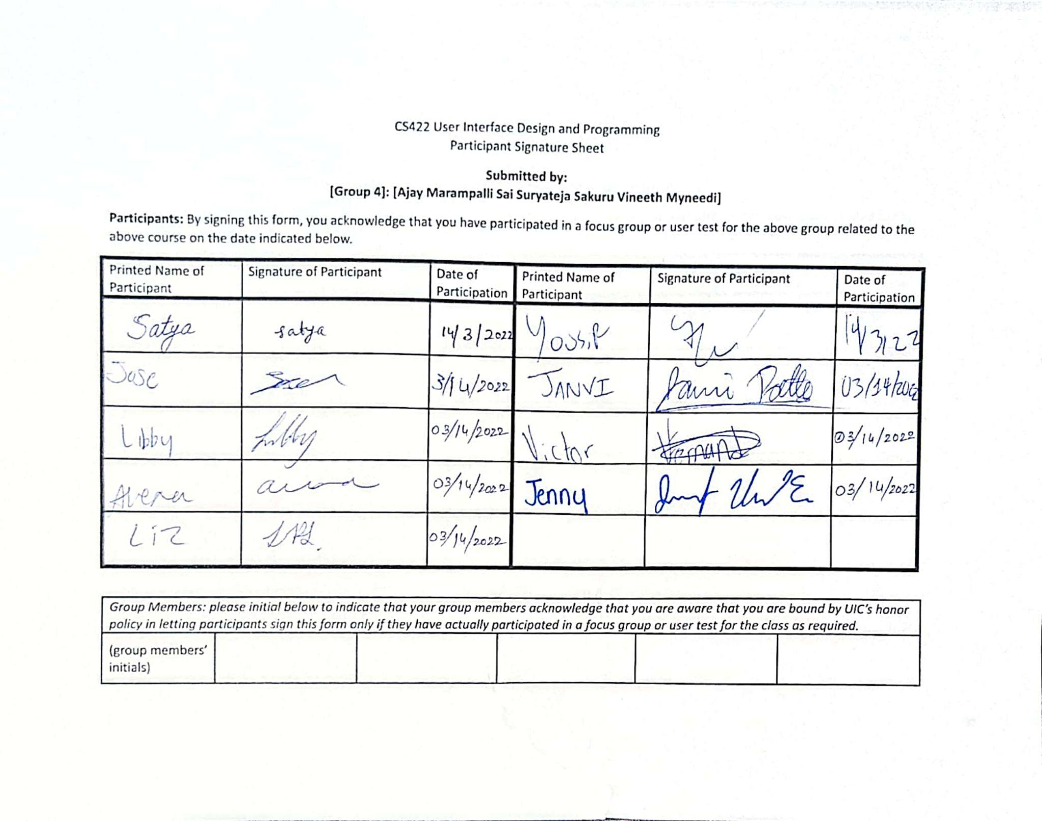

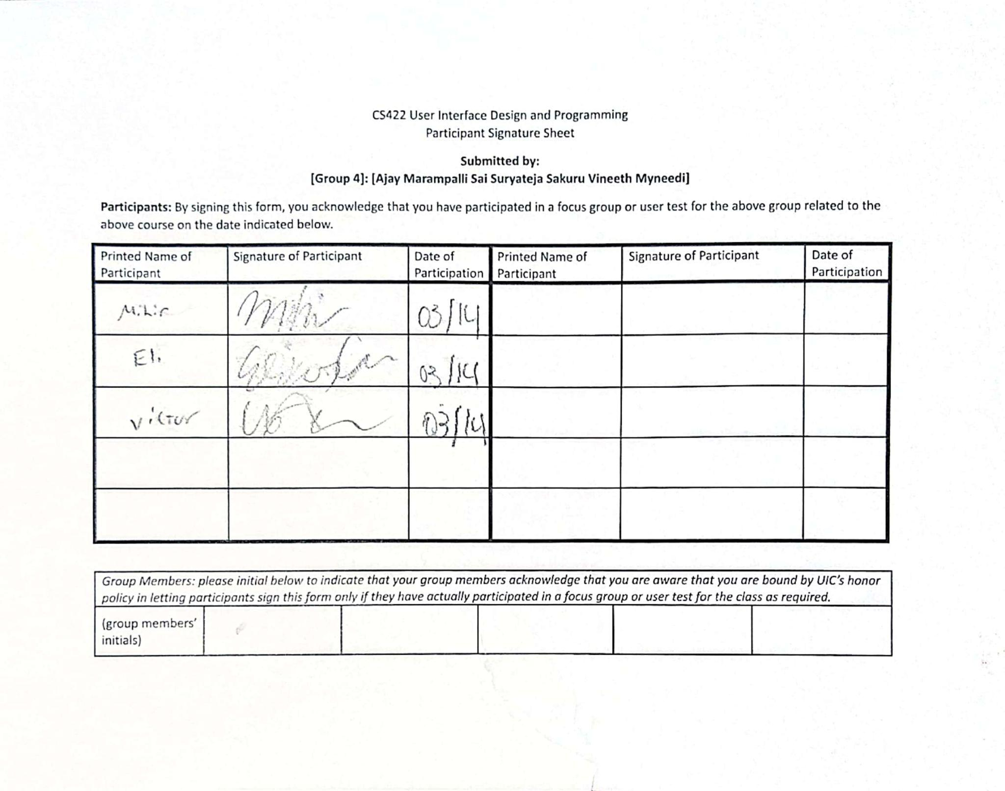

**Persona 3**

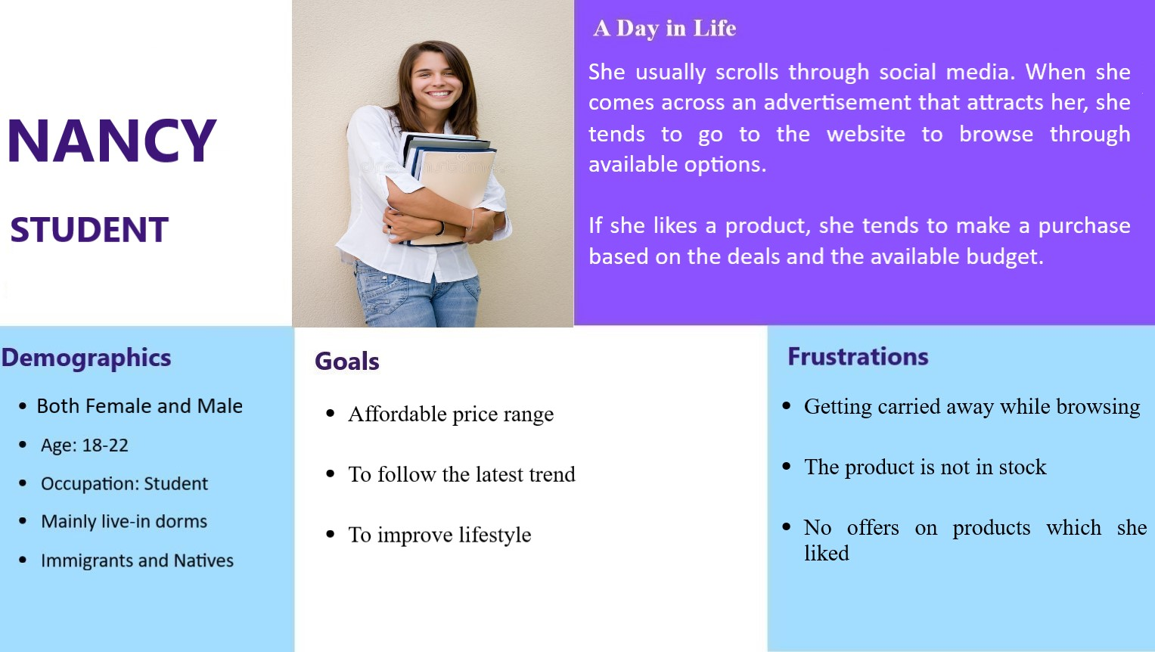

**Scenario 3**

**3. Out of stock**

User: Natasha is a student at UIC. She along with her friends plans on attending a rugby match to support UIC during the weekend wearing team t-shirts. But when they visit the university merchandise store, the product is out of stock and they are disappointed.

User Needs:

* Product availability
* Wait Time reduction
* Satisfaction
* Easy usability

Scenario: “Natasha usually goes to the store to buy university merchandise. Her university was hosting a major sporting event right around the corner. She along with her friends planned to attend the event wearing their favorite team t-shirt. The shirts were out of stock when they arrived at the store to purchase them before the match. The benefit of using our app is that you may pre-order the items you need days ahead of time, and the retailer will ensure that they have enough stock to meet the demand based on online orders and in-store sales. She and her friends may simply pre-order the t-shirts well in advance of the event and pick them up right before the event. The application is easy to use.”

**Storyboard 3 - Out of Stock**

